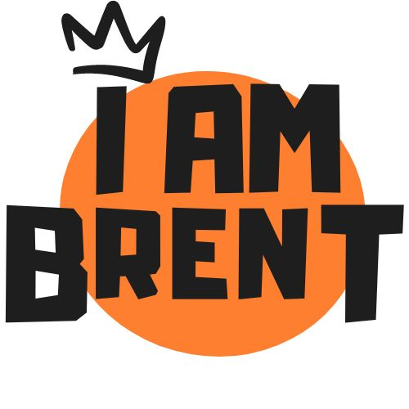

MyEnds – I AM Brent Community Microgrants – Round 1

Application Form

In your application, I AM Brent really wants to understand why the issue you are addressing is so important to the beneficiaries, what it is you will do to address this issue and how you will do it.

1. Please read the prospectus fully before completing this application form. It lists what I AM Brent will fund and the requirements for the application.
2. Please complete every section.

SECTION 1: Applicant details

Which type of applicant are you? (Please delete the response that does **not** apply.)

|  |  |  |  |
| --- | --- | --- | --- |
| Community member or members with a partner organisation | Yes/No | Organisation | Yes/No |

If you are a community member or members with a partner organisation, please give the details below for the lead community member.

Please ask your partner organisation to complete the rest of the form with you.

|  |  |  |
| --- | --- | --- |
| First name and surname  of lead community member | Telephone number | Email address |
|  |  |  |

SECTION 2: Organisation and contact details

|  |  |  |  |
| --- | --- | --- | --- |
| Organisation name |  | Organisation address |  |
| Organisation website |  | Social media accounts |  |
| Contact person |  | Job title |  |
| Email address |  | Telephone number |  |
| Type of organisation (e.g. charity, not for profit, unincorporated association) |  | When was the organisation established? (month/year) |  |
| Charity and/or company number |  | Last year’s annual turnover | £ |
| Is at least 25% of the organisation’s senior team and/or trustees from protected characteristic backgrounds?  Please describe. |  | | |

SECTION 3: Organisation’s work

|  |  |
| --- | --- |
| Describe the organisation's aims and main activities | *Max 150 words* |
| What makes the organisation stand out? | *Max 50 words* |
| How does the organisation apply safeguarding when working with young people? | *Max 150 words* |

SECTION 4: Bank account and policies

Does the organisation have the following? (Please delete the response that does **not** apply.)

|  |  |
| --- | --- |
| A bank account in the organisation’s name | Yes/No |
| Two different people required to authorise payments | Yes/No |
| Data protection policy | Yes/No |
| Equality, diversity and inclusion policy | Yes/No |
| Safeguarding policy | Yes/No |

SECTION 5: Grant proposal

|  |  |
| --- | --- |
| What is the main issue you are trying to address? | *Max 100 words* |
| How do you know that this is an issue that needs to be addressed? | *Max 150 words* |
| What is it that you will do to address this issue and why do you believe you can deliver it? | *Max 200 words* |
| Which one or more of the outcomes in Table 1 of the prospectus will the project demonstrate achievement against? |  |
| How will you measure the impact on the beneficiaries? | *Max 100 words* |
| How will the organisation involve beneficiaries in the design or delivery of the project? | *Max 150 words* |
| How will the organisation recruit the intended beneficiaries to the project and sustain their engagement? | *Max 150 words* |

SECTION 6: Beneficiaries

|  |  |
| --- | --- |
| In which hyperlocal area(s) will your project target beneficiaries? |  |
| Tell us about the beneficiaries your project will help. | *Max 150 words* |

SECTION 7: Proposed project budget

|  |  |  |
| --- | --- | --- |
| Item | Description | Amount (£) |
|  |  |  |
|  |  |  |
|  |  |  |
|  |  |  |
|  |  |  |
|  |  |  |
| Total | |  |

*Add extra lines if needed. VAT cannot be included.*

SECTION 8: References

Please provide **two** referees who we can contact to speak to about your organisation’s past work.

Referees can be organisations with whom your organisation has worked, a service user who has benefited from your organisation’s services, a donor who is funding or has funded your organisation, or some other person who you think can give evidence of your organisation’s work.

Please complete the table below only after confirming with the referees that they have consented to Step Up Hub contacting them and holding their personal details.

|  |  |  |  |
| --- | --- | --- | --- |
| First name and surname of referee | Organisation and  job title | Telephone number  and email | How they know your organisation’s work |
|  |  |  |  |
|  |  |  |  |

SECTION 9: Declaration

Person filling in the application form

|  |  |
| --- | --- |
| First name and surname | Job title |
|  |  |

Please complete the table below. (Please delete the response that does **not** apply.)

|  |  |
| --- | --- |
| I confirm that the information provided in this application form is true to the best of my knowledge. | Yes/No |
| I confirm that the organisation named in this application has given me authority to submit this application on its behalf. | Yes/No |
| I confirm that the grant applied for is for a new project and is enough to cover the project’s full cost. | Yes/No |
| I confirm that the organisation is able to spend this grant by 31 March 2026. | Yes/No |
| I agree to cooperate with any monitoring organised by Step Up Hub. | Yes/No |
| I agree to cooperate with any requests from Step Up Hub for marketing and for sharing of learning. | Yes/No |
| Is the organisation, or anyone connected to it, connected to Step Up Hub or have they worked with Step Up Hub before? | Yes/No |
| If the answer to the above question is “yes” please state under what circumstances they are connected to/have worked with Step Up Hub. |  |

SECTION 10: Next steps

Email this completed application form to [info@stepuphub.org](mailto:info@stepuphub.org) before 11.59pm Thursday 20 February 2025.